Topic 5.5

REACTIONS OF INORGANIC COMPOUNDS IN SOLUTION

Lewis Acids and Bases
Hydrated Metal Cations
Reactions of Complex Ions

LEWIS ACIDS AND BASES

A Lewis acid is a species which can bond by accepting a lone pair of electrons.
Metal cations behave as Lewis acids when they form coordinate bonds with ligands.

A Lewis base is a species which can bond by donating a lone pair of electrons.
Ligands behave as Lewis bases when they form coordinate bonds with metal cations.

HYDRATED METAL CATIONS

Most metal cations exist as the hexaaqua complex in solution. Main group metals form colourless ions but most transition metal ions are coloured.

[Fe(H₂O)₆]²⁺ | [Co(H₂O)₆]²⁺ | [Cu(H₂O)₆]²⁺ | [Al(H₂O)₆]³⁺ | [V(H₂O)₆]³⁺ | [Cr(H₂O)₆]³⁺ | [Fe(H₂O)₆]³⁺
pale green | pink | pale blue | colourless | green | pale green | yellow

These ions also exist in the solid state as hydrated ionic compounds.
[Co(H₂O)₆]²⁺ exists as [Co(H₂O)₆]Cl₂ or CoCl₂.6H₂O
The six water molecules are behaving as ligands:

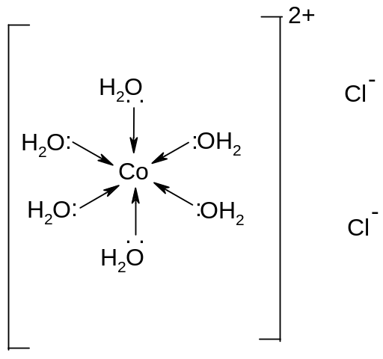

[Fe(H₂O)₆]²⁺ exists as [Fe(H₂O)₆]SO₄.H₂O or FeSO₄.7H₂O
Six of the water molecules are behaving as ligands, and the seventh is a water of crystallisation. It helps link the cation to the anion:

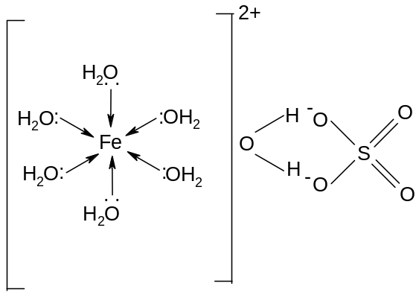

REACTIONS OF METAL COMPLEX IONS

- Deprotonation

Cations in aqueous solution are stabilised by the presence of aqua ligands, since the charge on the ion is distributed over a larger area and the polarising power is thus reduced.

If the charge density of the cation is particularly high, the electron density in the aqua ligand moves even closer to the cation and the bonds in the water are weakened. In such cases the hydrogen in the water ligand can be lost as a proton.

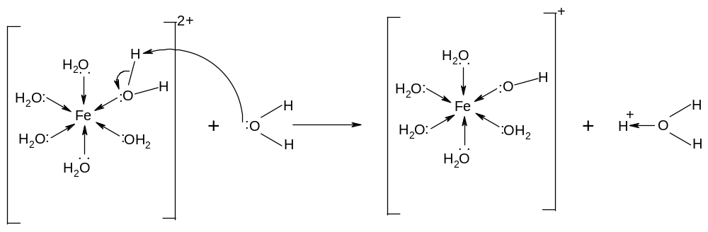

Eg [Fe(H₂O)₆]²⁺ == [Fe(H₂O)₅OH]⁺ + H⁺

This process is known as deprotonation.
Deprotonation is the loss of a proton by a water ligand to form a hydroxo ligand.

Deprotonation is caused by the high charge density on the central cation, which weakens the O-H bonds in the water ligands, and enables the H⁺ ( the proton) to leave.

The proton which is lost is given to a base. This can be water, hydroxide ions or ammonia. The extent to which deprotonation takes place depends on the strength of the base.

- Deprotonation by water

Water is a weak base. The hexaaqua complex will therefore behave as a weak acid and will partially dissociate:

Eg [Fe(H₂O)₆]²⁺(aq) + H₂O(l) == [Fe(H₂O)₅(OH)]⁺(aq) + H₃O⁺(aq)
Eg [Fe(H₂O)₆]³⁺(aq) + H₂O(l) == [Fe(H₂O)₅(OH)]²⁺(aq) + H₃O⁺(aq)
Eg [Cr(H₂O)₆]³⁺(aq) + H₂O(l) == [Cr(H₂O)₅(OH)]²⁺(aq) + H₃O⁺(aq)
Eg [Cu(H₂O)₆]²⁺(aq) + H₂O(l) == [Cu(H₂O)₅(OH)]⁺(aq) + H₃O⁺(aq)

Aqueous solutions of transition metal ions are thus acidic.

The greater the charge density on the central cation, the greater the extent of deprotonation and the more acidic the solution. For example, solutions of iron (III) salts are more acidic than solutions of iron (II) salts.

If the metal has a charge greater than +3, the aqua and hydroxocomplexes are unstable even after deprotonation. The polarising power of the cation is so high that it is not stabilised even by deprotonation. They are only stable if all protons are removed to form an oxoanion:

Eg [V(H₂O)₆]⁵⁺, [Cr(H₂O)₆]⁶⁺ and [Mn(H₂O)₆]⁷⁺ are not stable - the cations are too polarising. Instead they exist as VO₂⁺ or VO₃⁻, Cr₂O₇²⁻ or CrO₄²⁻, and MnO₄⁻ respectively.

- Deprotonation by hydroxide ions

i) a few drops

The hydroxide ion is a strong base. It will pull protons away from water ligands more than water molecules, and more than one deprotonation will take place.
In all cases, the hydrated hydroxide will be formed:

Eg [Fe(H₂O)₆]²⁺(aq) + 2OH⁻(aq) == [Fe(H₂O)₄(OH)₂](s) + 2H₂O(l)
Iron (II) hydroxide
Eg [Cu(H₂O)₆]²⁺(aq) + 2OH⁻(aq) == [Cu(H₂O)₄(OH)₂](s) + 2H₂O(l)
Copper (II) hydroxide
Eg [Cr(H₂O)₆]³⁺(aq) + 3OH⁻(aq) == [Cr(H₂O)₃(OH)₃](s) + 3H₂O(l)
Chromium (III) hydroxide
Eg [Fe(H₂O)₆]³⁺(aq) + 3OH⁻(aq) == [Fe(H₂O)₃(OH)₃](s) + 3H₂O(l)
Iron (III) hydroxide
The hydroxides are all insoluble, since they are covalent. Thus a precipitate is formed when sodium or potassium hydroxide solution is added to any solution containing transition metal cations.

Fe(OH)₂ | Co(OH)₂ | Cu(OH)₂ | Al(OH)₃ | Cr(OH)₃ | Fe(OH)₃
Green | Blue | pale blue | white | Green/grey | brown

ii) in excess

In some cases ie (Cr³⁺ and Al³⁺), the hydroxide ions can remove even more protons, and hydroxoanions are formed:

Eg [Cr(H₂O)₃(OH)₃](s) + 3OH⁻(aq) == [Cr(OH)₆]³⁻(aq) + 3H₂O(l)
Green/grey precipitate green solution
Eg [Al(H₂O)₃(OH)₃](s) + 3OH⁻(aq) == [Al(OH)₆]³⁻(aq) + 3H₂O(l)
White precipiate colourless solution

Al(OH)₆³⁻ | Cr(OH)₆³⁻
Colourless | Green

In such cases the precipitate is found to redissolve in excess alkali to give a solution.
Metal hydroxides which dissolve in excess alkali are said to be amphoteric.

Some metal hydroxides, such as Fe(OH)₂(H₂O)₄ and Fe(OH)₃(H₂O)₃, do not dissolve in excess alkali. Such hydroxides are said to be basic.

iii) reaction of hydroxides with acid

The precipitates can all be converted back to the hexaaqua complex by the addition of acid:
Eg [Cr(H₂O)₃(OH)₃](s) + 3H₃O⁺(aq) == [Cr(H₂O)₆]³⁺(aq) + 3H₂O(l)
Eg [Al(H₂O)₃(OH)₃](s) + 3H₃O⁺(aq) == [Al(H₂O)₆]³⁺(aq) + 3H₂O(l)

- Deprotonation by ammonia

Ammonia is also a stronger base than water, so can also cause deprotonation of the hexaaqua complex and form the hydroxide precipitate:

Eg [Fe(H₂O)₆]²⁺(aq) + 2NH₃(aq) == [Fe(H₂O)₄(OH)₂](s) + 2NH₄⁺(aq)
Iron (II) hydroxide
Eg [Cu(H₂O)₆]²⁺(aq) + 2NH₃(aq) == [Cu(H₂O)₄(OH)₂](s) + 2NH₄⁺(aq)
Copper (II) hydroxide
Eg [Cr(H₂O)₆]³⁺(aq) + 3NH₃(aq) == [Cr(H₂O)₃(OH)₃](s) + 3NH₄⁺(aq)
Chromium (III) hydroxide
Eg [Fe(H₂O)₆]³⁺(aq) + 3NH₃(aq) == [Fe(H₂O)₃(OH)₃](s) + 3NH₄⁺(aq)
Iron (III) hydroxide

The ammonia is not a sufficiently strong base to cause further deprotonation, so the hydroxoanions are not formed with excess ammonia.

- Deprotonation by carbonate ions

Carbonate ions are bases and can deprotonate the +3 ions to form the hydroxide precipate. The carbonate ions are converted into carbon dioxide gas.

2[Fe(H₂O)₆]³⁺(aq) + 3CO₃²⁻(aq) → 2[Fe(H₂O)₃(OH)₃](s) + 3CO₂(g) + 3H₂O(l)
2[Cr(H₂O)₆]³⁺(aq) + 3CO₃²⁻(aq) → 2[Cr(H₂O)₃(OH)₃](s) + 3CO₂(g) + 3H₂O(l)
2[Al(H₂O)₆]³⁺(aq) + 3CO₃²⁻(aq) → 2[Al(H₂O)₃(OH)₃](s) + 3CO₂(g) + 3H₂O(l)

The +2 ions, however do not deprotonate so readily and do not behave as acids in the presence of carbonate ions. Instead they form a precipitate directly with the carbonate ion. No carbon dioxide is evolved.

[Fe(H₂O)₆]²⁺(aq) + CO₃²⁻(aq) → FeCO₃(s) + 6H₂O(l)
[Co(H₂O)₆]²⁺(aq) + CO₃²⁻(aq) → CoCO₃(s) + 6H₂O(l)
[Cu(H₂O)₆]²⁺(aq) + CO₃²⁻(aq) → CuCO₃(s) + 6H₂O(l)

FeCO₃ | CoCO₃ | CuCO₃
green | pink | green-blue

- Ligand exchange

Ligand exchange is the replacement of one ligand by another in a complex.
Many ligands are capable of replacing water in transition metal complexes, but only two will be considered:

- ligand exchange by ammonia

With hexaaqua complexes, ammonia acts as a base and facilitates deprotonation. Excess ammonia, however, will undergo ligand exchange with some hydroxides, replacing aqua and hydroxo ligands with ammine ligands.

With Co(H₂O)₄(OH)₂ the substitution is complete:
[Co(H₂O)₆]²⁺(aq) + 2NH₃(aq) == [Co(OH)₂(H₂O)₄](s) + 2NH₄⁺(aq)
Pink solution → blue precipitate
[Co(H₂O)₄(OH)₂](s) + 6NH₃(aq) == [Co(NH₃)₆]²⁺(aq) + 4H₂O(l) + 2OH⁻(aq)
blue precipate → straw-coloured solution
The complex [Co(NH₃)₆]²⁺ is oxidised to [Co(NH₃)₆]³⁺ on standing in air:
[Co(NH₃)₆]²⁺ → [Co(NH₃)₆]³⁺ + e
straw-coloured solution → brown solution

With Cu(H₂O)₄(OH)₂ the substitution is incomplete:
[Cu(H₂O)₆]²⁺(aq) + 2NH₃(aq) == [Cu(H₂O)₄(OH)₂](s) + 2NH₄⁺(aq)
pale blue solution → pale blue precipitate
[Cu(H₂O)₄(OH)₂](s) + 4NH₃(aq) == [Cu(NH₃)₄(H₂O)₂]²⁺(aq) + 2H₂O(l) + 2OH⁻(aq)
pale blue precipitate → dark blue solution

The hydroxides of chromium, iron (II), iron (III) and aluminium do not dissolve in aqueous ammonia.

On slow addition of ammonia to a solution containing aqua complexes of Co²⁺ and Cu²⁺, a precipitate is formed of the hydroxide, which redissolves in excess ammonia to give a solution again.

Co(NH₃)₆²⁺ | Cu(NH₃)₄(H₂O)₂²⁺
straw | Dark blue

Note than when ammonia replaces water as ligands, the coordination number does not change. This is because water and ammonia are small ligands with no charge, so they don’t get in each other’s way or repel each other too much. Therefore both form octahedral complexes.

- ligand exchange by chloride ions

In the presence of concentrated hydrochloric acid, the chloride ions can replace the water ligands in some complex ions and form an anionic complex:

[Cu(H₂O)₆]²⁺(aq) + 4Cl⁻(aq) == [CuCl₄]²⁻(aq) + 6H₂O(l)
pale blue solution → yellow solution
[Co(H₂O)₆]²⁺(aq) + 4Cl⁻(aq) == [CoCl₄]²⁻(aq) + 6H₂O(l)
pink solution → blue solution

Note than when chloride ions replace water ligands, the coordination number decreases from 6 to 4. This is because chloride ions are large and negatively charged, so they repel each other more are cannot pack so closely together.

These reactions are favoured because they cause an increase in entropy. There are 5 species on the left hand side of the equation and 7 species on the right. The entropy of the system thus increases.
This is counterbalanced, however, by the fact that more coordinate bonds (6) are broken than are formed (4), and that chloride ligands do not form very strong coordinate bonds. The reaction is thus endothermic.

These reactions are generally readily reversible, and addition of water to the solution will cause the chloride ligands to be replaced by aqua ligands. This reaction is used in the test for water; blue cobalt chloride paper turns pink in the presence of water.
[CoCl₄]²⁻(aq) + 6H₂O(l) == [Co(H₂O)₆]²⁺(aq) + 4Cl⁻(aq)
blue pink

CoCl₄²⁻ | CuCl₄²⁻
blue | green/yellow

- ligand exchange by polydentate ligands

Polydentate ligands such as H₂NCH₂CH₂NH₂, C₂O₄²⁻ and edta⁴⁻ readily replace water ligands in complex ions. The resulting complex ions always remain six coordinate:

[Fe(H₂O)₆]³⁺(aq) + 3NH₂CH₂CH₂NH₂(aq) == [Fe(H₂NCH₂CH₂NH₂)₃]³⁺(aq) + 6H₂O(l)
[Cr(H₂O)₆]³⁺(aq) + 3C₂O₄²⁻(aq) == [Cr(C₂O₄²⁻)₃]³⁻(aq) + 6H₂O(l)
[Cu(H₂O)₆]²⁺(aq) + edta⁴⁻(aq) == [Cu(edta)]²⁻(aq) + 6H₂O(l)

These reactions are favoured because they cause an increase in entropy. There are always less species on the left hand side of the equation than on the right. The entropy of the system thus increases, and multidentate complexes are therefore more stable than complexes involving monodentate ligands.

This is known as the chelate effect.

The entropy increase is not counterbalanced by a decrease in coordination number as the coordination number is still 6.

3. Other reactions of metal ions in solution

Some transition metals can form more than one species with the same oxidation state in solution: eg Cr₂O₇²⁻(aq) and CrO₄²⁻(aq), or VO₃⁻(aq) and VO₂⁺(aq)

The stability of the species generally depends on the pH of the solution – the species with less oxygen per metal ion will be stable in acidic solution, and the species with more oxygen per metal ion will be stable in alkaline solution. The two species can be interconverted by adding acid or alkali:

2CrO₄²⁻(aq) + 2H⁺(aq) → Cr₂O₇²⁻(aq) + H₂O(l)
yellow orange
Cr₂O₇²⁻(aq) + 2OH⁻(aq) → 2CrO₄²⁻(aq) + H₂O(l)
orange yellow

VO₃⁻(aq) + 2H⁺(aq) → VO₂⁺(aq) + H₂O(l)
yellow
VO₂⁺(aq) + 2OH⁻(aq) → VO₃⁻(aq) + H₂O(l)
yellow

4. Summary of reactions of metal ions in aqueous solution

Many of these reactions are characterised by clear colour changes. A summary of the colour changes occurring is in the table below:

Ion | With NH₃ or NaOH, not in excess | With excess NaOH | With excess NH₃ | With conc. HCl | With Na₂CO₃
[Fe(H₂O)₆]²⁺  pale green soln | dirty green ppt | Insoluble | Insoluble | - | Green ppt  (carbonate)
[Al(H₂O)₆]³⁺  colourless soln | White ppt | Colourless solution | Insoluble | - | White ppt  (hydroxide)
[Cr(H₂O)₆]³⁺  pale green soln | pale green ppt | green soln | Insoluble | - | Pale green ppt  (hydroxide)
[Fe(H₂O)₆]³⁺  yellow soln | brown ppt | Insoluble | Insoluble | - | Brown ppt  (hydroxide)
[Co(H₂O)₆]²⁺  pink soln | blue ppt | Insoluble | straw soln  (darkens on standing) | blue soln | Pink ppt  (carbonate)
[Cu(H₂O)₆]²⁺  blue soln | pale blue ppt | Insoluble | Deep blue soln | yellow soln | Green/blue ppt  (carbonate)

